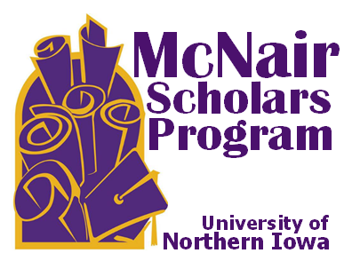
MCNAIR SCHOLARS PROGRAM
UNIVERSITY OF NORTHERN IOWA
Biography Form
Please complete and return to:
McNair Scholars Program
Honors Cottage 109
mcnair@uni.edu
To promote our students and showcase all that they do, we request that you fill out this form telling a little bit about yourself.

Student’s Name: ___________________________________ Date: _____________________

- Hometown:
______________________________________________________________________________

- Year in school: Sophomore Junior Senior Graduate Student

Other: ________________________________________________________________________

- Major(s):
__________________________________________________________________________________________________________________________________________________________________________

- Minor(s)/Certificates/Etc.:
__________________________________________________________________________________________________________________________________________________________________________

- Student organizations, jobs, volunteer activities involved with:
__________________________________________________________________________________________________________________________________________________________________________

- Future plans:
__________________________________________________________________________________________________________________________________________________________________________

- Why did you join the McNair Scholars Program:
__________________________________________________________________________________________________________________________________________________________________________

- Research Interests
__________________________________________________________________________________________________________________________________________________________________________

- Any other information you would like to include (i.e. awards received, scholarships, interests):
__________________________________________________________________________________________________________________________________________________________________________

McNair Scholars Program ● Honors Cottage 109 ● University of Northern Iowa ● Cedar Falls, IA 50614-0345 On-Campus Mail Code: 0345 ● Phone (319) 273-2284 ● Fax (319)273-2982 ● mcnair@uni.edu ● www.uni.edu/web/mcnair

